PRE-REQUISITES

* Azure Subscription Account
* Create ASP.NET Core 6 Web API Project

NOTES:

* Select region that is nearest on your user location.
* As practice, select same region for every resources.
* Add abbreviation at the end of resource name. Example: add abbr "rg" (resource-group) => resource name: myfirstwebapp-win-demo-rg

STEP 1: Creating a resource group (ex. myfirstwebapp-win-demo-rg)

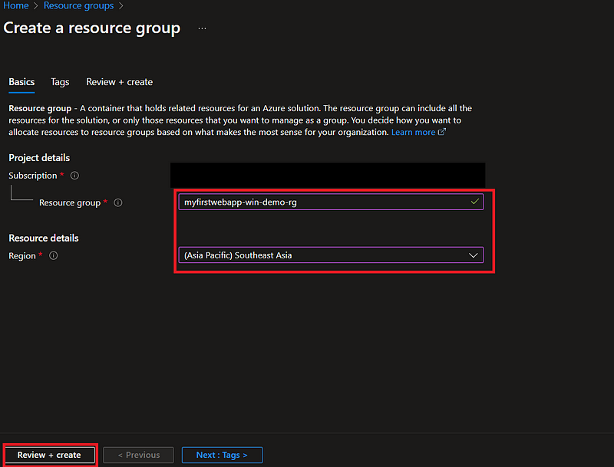

STEP 2: Creating an app service plan (ex. myfirstwebapp-win-demo-asp)

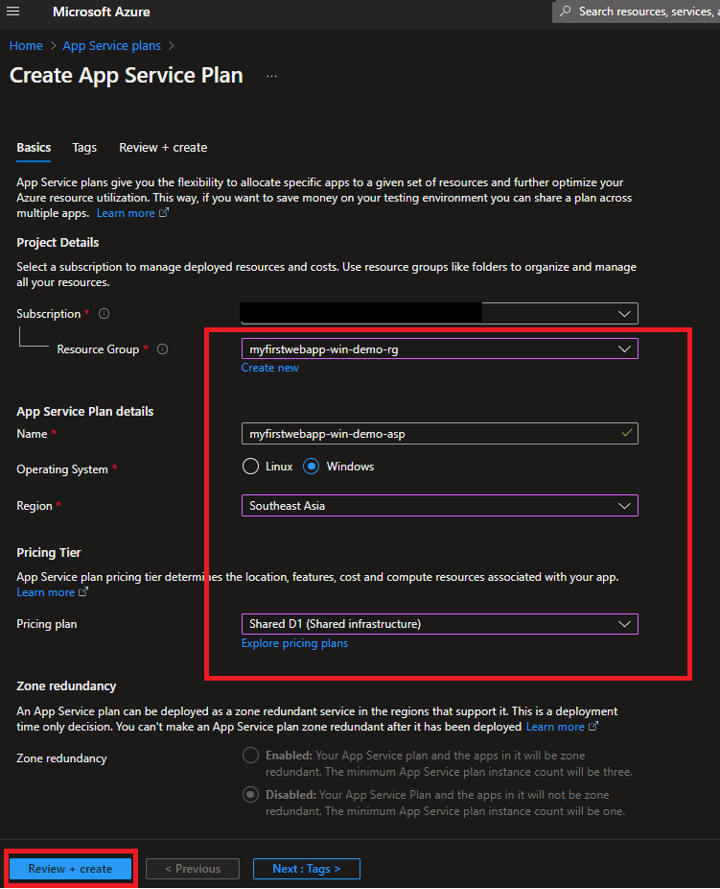

STEP 3: Creating an web app/app service (ex. myfirstwebapp-win-demo)

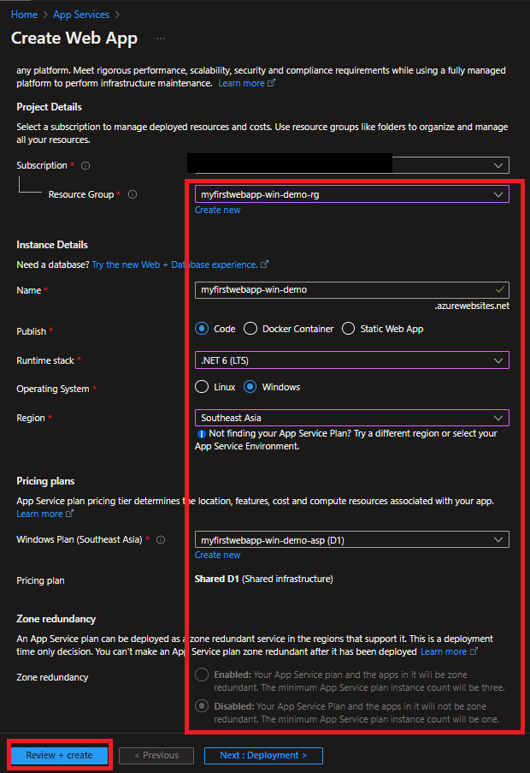

STEP 4: Creating sql database server (ex. myfirstwebapp-win-demo-dbserver)

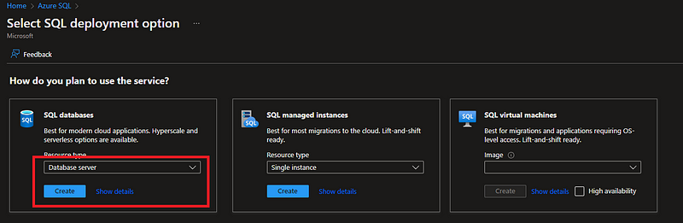

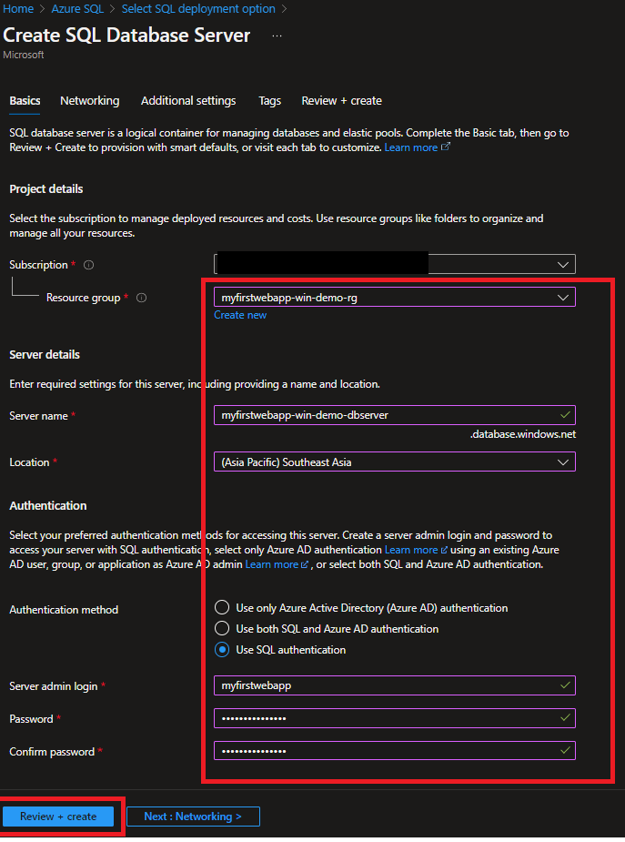

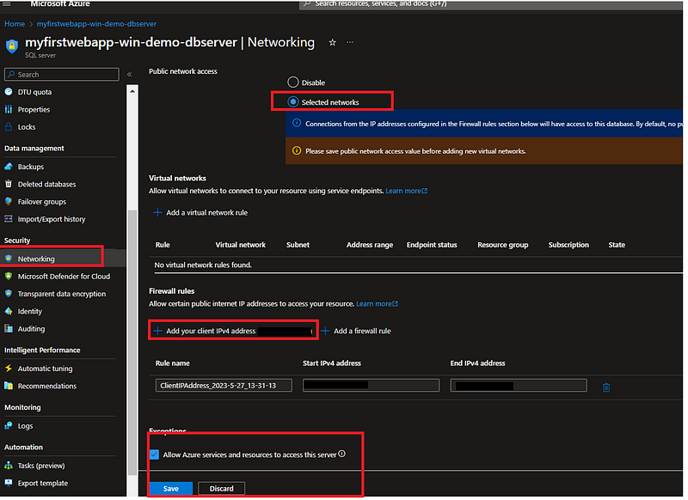

STEP 5: Creating sql database (ex. myfirstwebappdb)

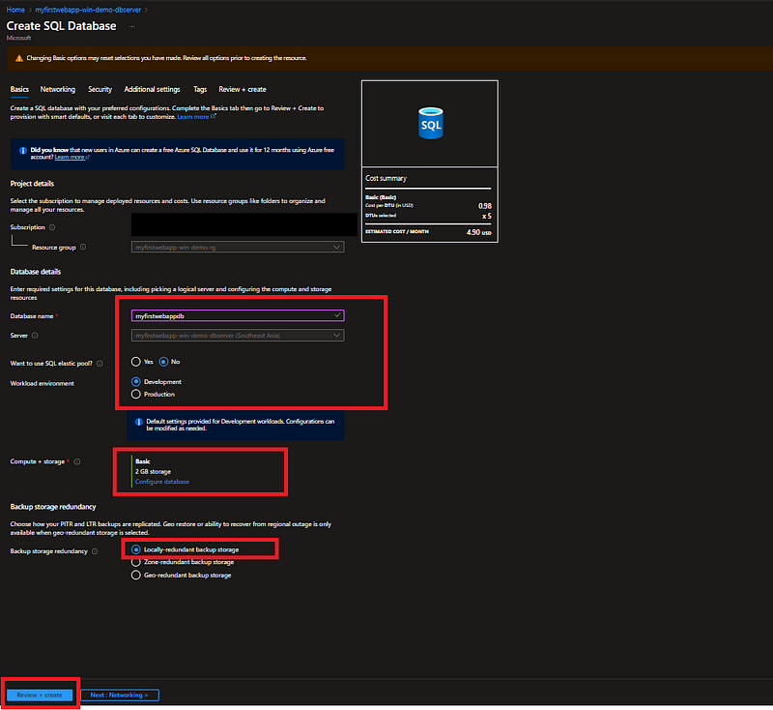

STEP 6: Create appsettings.json for particular environment and put those configuration in Azure Configuration

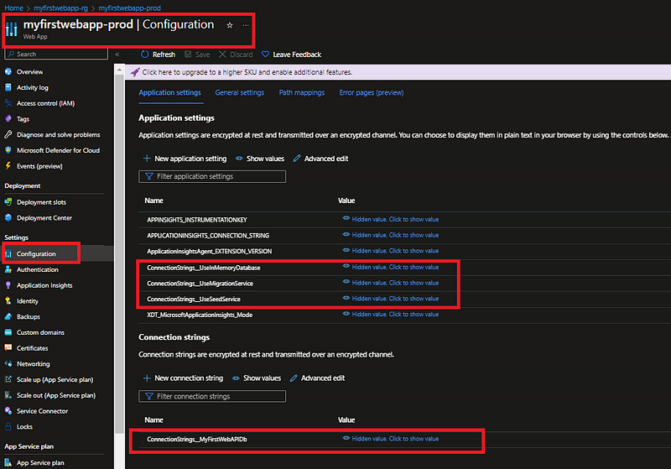

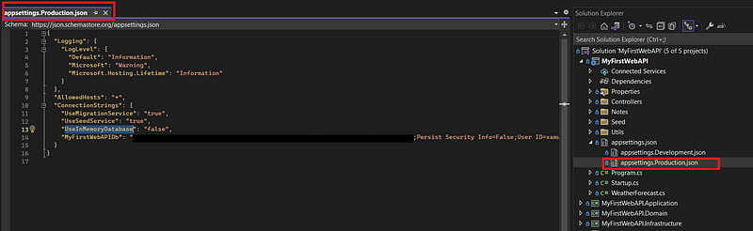

Step 7: Deploy ASP.NET Core to Azure

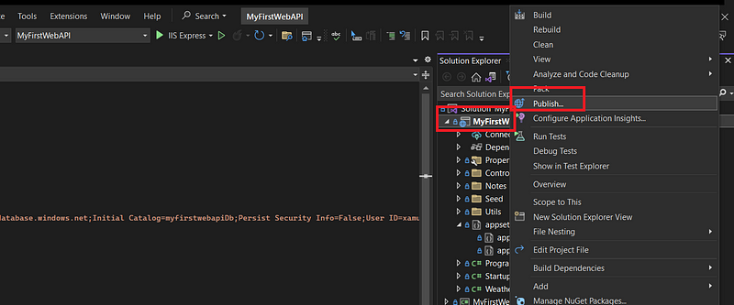

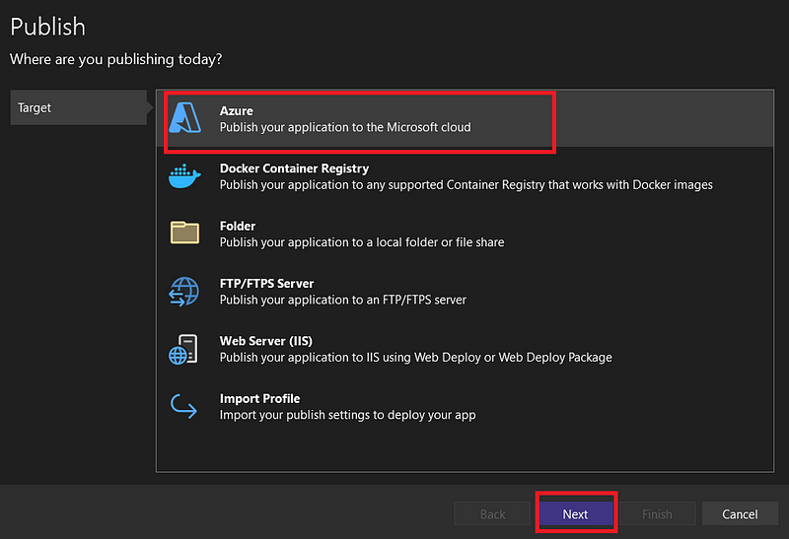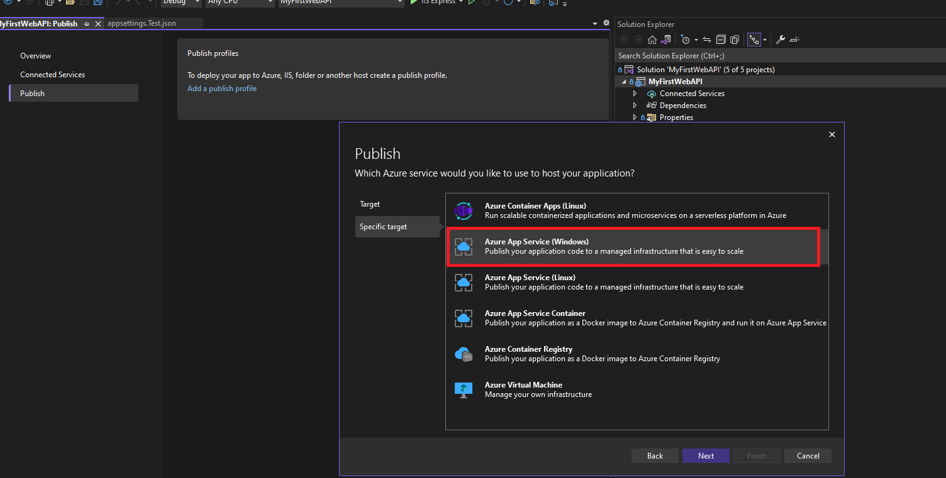

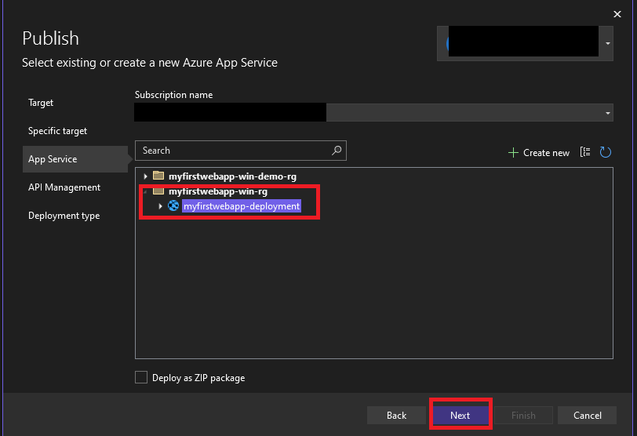

Skip API Management

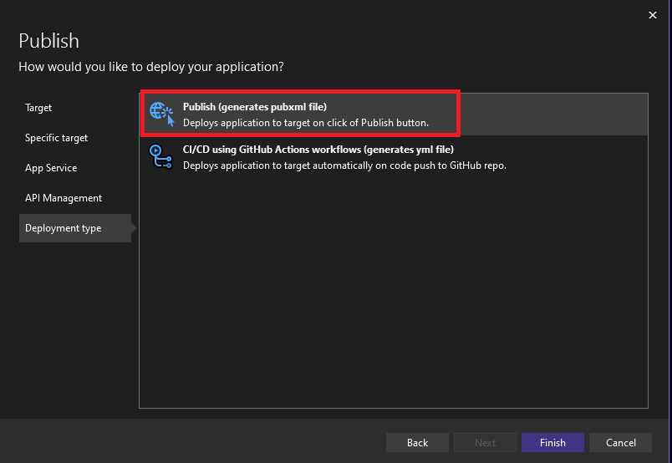

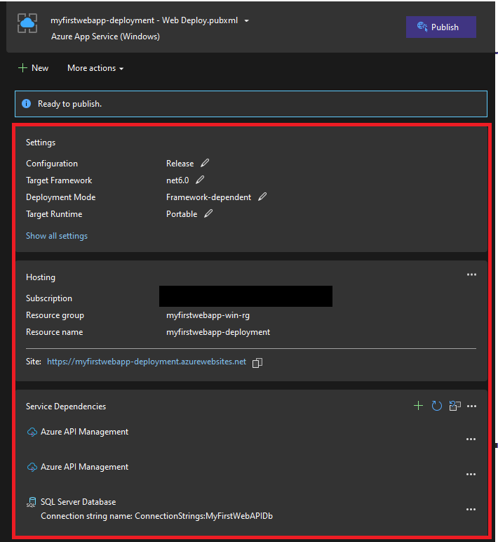

Next thing to do is Testing our APIs

